**UNIVERSITY OF LONDON**

**BSc Computer Science**



**CM3070 FINAL PROJECT**

**FINAL PROJECT DRAFT REPORT**

Task Manager Mobile Application

Name: Shanath S/O Rajendran

UoL ID: 210470552

Contents

Introduction 3

Literature Review 4

Time Management 4

The Effectiveness of Goal Visualization 6

Comparison of Existing Applications 7

Project Design 10

Domain & Users 10

Justification of Selected Features 10

Technology & Methodology 11

Design Structure 12

Low Fidelity Wireframe 13

Gantt Chart 13

Feature Prototype 14

Evaluation 15

References 16

Appendix 19

# Introduction

The template chosen for this final project, is the Project Idea Title 1: Task Manager Mobile App from CM3050 Mobile Development.

The idea for this project comes from my own personal experience, where I have downloaded task manager applications in the past, but never consistently used them because the application was either not engaging enough, or it was aesthetically unappealing.

**Why is this important?**

We live in a fast-paced world, most of us reside in cities. City life is stressful. We have lots of responsibility and obligations to fulfil on a regular basis. We might have multiple places to be in a day. Thus, we need a way to track and manage our tasks. Coupled with the fact that we have too many distractions in the modern world, due to rapidly emerging technology, like social media and games, it can be hard to stay focused on our responsibilities.

The objectives for this final project are as follows:

* Define the scope of the project
* Conduct a literature review to support the development of the project
* Build a task manager mobile application for Android
* Allow users to take notes, create a checklist with calendar integration, utilize a timer for time management, and project tool to undertake large scale tasks.
* Deploy it to the Google Play Store
* Have my target demographic review the application, and ascertain if it outperforms what’s currently out on the market.

The deliverables for this final project are as follows:

* An initial preliminary report showcasing the chosen project template and the path ahead.
* The source code for the mobile application.
* A final report detailing the entirety of the project, including the full development, application testing, user feedback compilation and deployment unto the Google Play Store.
* A video demonstration showcasing the mobile application at work.
* The evaluation results of the project.

The following sections will comprise of literature reviews to support the need of having a time management and project management tool. Followed by an overview of the intended audience, technologies to be used, wireframes that will be tested by survey respondents, and a Gantt Chart outlining the path ahead in completing this final project, finishing off with a prototype implementation of the discussed features.

# Literature Review

In today's fast-paced, digitally distracting world, effective time management and goal-setting are crucial for students and adults. This literature review informs the development of a task manager application by exploring three key areas:

1. **Time Management Techniques**: Examines the impact on productivity and academic performance. As the application will incorporate the 52/17 technique for time management, where you work for 52 minutes, and rest for 17 minutes, reviewing the scholarly works that back up the benefits of intermittent breaks is needed.
2. **Goal Setting and Visualization**: Highlights their roles in motivation and project management, as the application offering features to track and visualize progress via a project management tool.
3. **Comparative Analysis of Productivity Apps**: Identifies key features and shortcomings to address unmet needs.

## Time Management

Nasrullah and Khan from the University of Peshawar and Gomal[1], conducted a study to evaluate the strengths and weaknesses of time management practices on student academic performance. Recognizing the importance of proper time management in today's competitive environment[2], the study focused on time management mechanisms and goal setting among students from Qurtuba University of Science and Technology, Pakistan. Surveys assessed students' short-term and long-term time management capabilities. The data analysis included descriptive statistics and correlation analysis to explore the relationship between time management practices and academic performance.

The results showed a positive correlation between time management and the student’s academic performance. It revealed that there is a connection when it comes to academic performance and stress reduction, when utilizing time management practices. The study showed relevance and practicality to address the issue of student’s academic performance as well as using robust analytical tools to tabulate their findings. However, the sample size chosen was rather small, only a total of 120 students, lacking diversity of participants form various regions. Therefore, care has to be taken as it may not be wise to generalize the findings to all student populations globally.

A research conducted by Albulescu and colleagues, from the University of Timioara, Romania[3], delved into the effectiveness of taking micro-breaks and its impact on performance. The study was an analysis of conducted studies in the relevant field over the last 30 years on the subject of micro breaks, on whether taking short breaks of 10 minutes or less, when performing a task, leads to better performance without accumulating too much strain on the person to the point where it affects their health.

Out of 4868 case studies drafted, 22 studies were finalized and narrowed down for the analysis. The participants chosen in the selected studies were healthy individuals which included both students and young adults. The measurements that were monitored and classified in this analysis were vigor, fatigue or performance. Vigor being an individual’s inclination to carry on with the task at hand, even when challenges present themselves, while fatigue relates to how tired the individual is. The performance measurements relate to whether the individual was able to perform his or her task with high degree of accuracy and precision. Tasks participants had to perform were classified into three categories. Creative, clerical and cognitive tasks. All 22 studies had a control group as a comparison, such as those with micro break and those without.

The collective findings of the chosen studies concluded that micro breaks do indeed improve the performance and vigor of the individual whilst reducing fatigue for clerical and creative tasks, though there was barely any improvement for cognitive intensive tasks. The data uncovered that those who took breaks that were longer than 10 minutes, generally had better performance.

However, there were several key factors that had to be considered for further study. The duration of the micro break could not be decisively agreed upon by experts in the field. The tasks in which an individual partakes prior to the break, also mattered greatly, as well as the activity the individual partakes during their break. An improvement to this analysis could have been taking the findings of the conducted studies, and perform a new bespoke experiment, comparing the results of different intervals of rest period between control groups. I also uncovered that the country in which these case studies were selected from was not mentioned, only that they were taken in English. Perhaps a comparative study could be made between individuals form different regions of the world, like Asia and Europe, to see if there were any noticeable differences in performance when micro-breaks were given. It shared a similar weakness from the first study reviewed, where diversity was lacking. But I do agree with the findings that micro-breaks are needed in order for an individual to remain productive, as based off the research above, an individual’s performance is tied to how well he or she manages their time and workload.

This literature review analyzed two studies from 2015 and 2022, emphasizing the importance of time management today. The findings showed that practices like planning and intermittent breaks enhance performance in tasks such as studying or working. This supports the need for a task manager app incorporating the 52/17 technique, which aids students in focusing and planning study schedules with timed work and breaks.

## The Effectiveness of Goal Visualization

Cheema and Bagchi[4] explored how visualizing goals impacts an individual's sustained effort towards achieving objectives. Their study showed that intuitive, short-term goals are perceived as easier to reach, especially when broken into sub-tasks. Visualization was found to make goals appear nearer and increase effort and efficiency in pursuing them, highlighting the power of visualization and its effectiveness when goals are clearly defined.

A total of five studies were conducted to assess the effects of goal visualization.

The first study took 68 Olympic swimmers and had them swim 30 laps, each of which was a 100m. The measurements used was to take the difference in swim times of the first 50m, when the swimmer was facing away from the finish line, and the last 50m, when the swimmer was able to see the finish line, hence, able to visualize the end goal. The results revealed that the time difference decreased as the swimmer neared the finish line, showing a positive influence on the swimmer when he was approaching the goal, despite the presence of fatigue.

The second study had 79 students sustain grip pressure for 130 seconds, split into two groups. One group viewed a horizontal progress bar, while the other saw a stopwatch at 30-second intervals. Results showed that the group with the stopwatch exerted significantly less pressure towards the end, whereas those with the progress bar maintained more uniform pressure. This suggests that visualizing goal proximity helps sustain effort.

The third study took 183 undergraduates and tasked them to save $750 for a fabricated vacation to Europe. There were two groups, one that could easily visualize their savings with a horizontal bar that was shaded depending on how much was already saved, 30% or 70%, whilst the other control group was only given textual representation of the savings amounts. The measurements used was a scale given to the participants to assess their commitment to reaching the required amount. The scale was based off Wright and Kacmar[5]. The results revealed those given the bar that made visualizing the amount left to save up, committed greater effort to saving than those that had a difficult time visualizing.

Just off these three studies, participants with goal visualization, like a progress bar, outperformed those without it, in endurance tests. These findings suggest that visualizing goals boosts effort and motivation, supporting the feature a project management tool with visual feedback, such as a progress bar, to track progress and remaining tasks.

However, the studies conducted above do leave room for question as to the factors that could contribute to how likely an individual is able to outperform another, given that both has access to easy visualization tools. For example, the undergraduates whose grip strength was tested, could house bias to the strength of the individual. A student with phenomenal grip strength and endurance could exert the most amount of willpower and willingness to complete the test, regardless of what goal visualization tool he was given. Thus, it is important to note an individual’s characteristics and personality might be a contributing factor when to comes to accomplishing goals.

## Comparison of Existing Applications

The following is a review of similar applications that have already been published on the Google Play Store. These competitors were selected for analysis due to their popularity for Android Devices.

Microsoft To Do[6] is a to-do list mobile application developed by Microsoft for Android and IOS devices(Figure 1). The analysis of the application are as follows:

1. Users must sign in or create an account to use the application, which may drive them to competitor apps if they don't wish to log in[7].
2. The app lacks a tutorial, making it hard for users to discover all features.
3. The application’s aesthetic could be improved. The contrast between the black top bar and white main container, affects readability of the text, and contrast of colors is one of the key areas in GUI design[8].
4. Wang and colleagues[9] noted that students face significant digital distractions. A focus tool to help manage time and minimize these distractions, as discussed in the Time Management section, would be beneficial.
5. A study done by the U.S. Department of Labor[10] showed that 78% of the population, spent their days engaged in household activities while 44% of the population were engaged in work/work related activities. This indicates users have many tasks to accomplish. The application lacks a project management tool to meet this need.

Google Tasks[11] integrates seamlessly with other Google services like Gmail and Google Calendar, allowing users to create, view, and manage tasks across multiple platforms (Figure 2). The analysis of the application are as follows:

1. Google allows users to access basic to-do list features without signing in. Users can log in to sync tasks with Gmail and Google Calendar.
2. Has no tutorial, making it difficult for users to uncover all the available features.
3. Google has adopted is the flat UI approach[12]. This provides a clean and easy interface to navigate.
4. A tool that could aid students in focusing and managing their time, as discussed in the Time Management section, could prove fruitful.
5. No tool for users to undertake and manage large scale projects, and houses no way to visualize the progress being made.
6. Does not allow users to upload and attach images as part of their notes.

Tasks by Pocket Brilliance[13]. A review of this application reduces the bias of only analyzing task manager applications from already established technology giants (Figure 3).

The analysis of the application are as follows:

1. It uses minimal API such as calendar, syncs the application and its data across multiple devices. It does not require users to log in. However, it requires users to purchase the premium version of the application, in order to synchronize across devices.
2. This application does not collect or share user’s data, a good practice to entice users to use their application, as data collection from corporations is rampant in today’s world[14].
3. Has a poor tutorial that only activates once users start to interact with the application. It does not give the option to replay the tutorial in the settings page, which is extremely cluttered.
4. Adopted a flat UI approach.
5. No tool that could aid students in focusing and managing their time, as discussed in the Time Management section.
6. No tool for users to undertake and manage large scale projects, and houses no way to visualize the progress being made.

Key Takeaways

The findings uncovered from the analysis, that will be carried over to my application, are highlighted under the “Carry Over” column. These features were selected to provide the best experience to users, whilst eliminating potential inconveniences. Moreover, the literature review conducted on time management and goal visualization provides the justification for the intended features of the application, such as the need for a project management and focus tool.

|  |  |  |  |
| --- | --- | --- | --- |
| Name of Application | Good Practices | Bad Practices | Carry Over |
| Microsoft To Do | * Allows customization via images | * Forcing users to sign in * Bad design principle * No tutorial * No focus tool * No project tool | * Allow image customization * Include focus & project tool * Include a tutorial * Do not force users to sign in * Select proper design principles |
| Google Tasks | * Great UI design choice, flat principle | * No tutorial * No focus tool * No project tool * Can’t attach images | * Carry over flat principle and minimalism design * Include focus & project tool * Include a tutorial |
| Tasks by Pocket Brilliance | * Minimalize use of 3rd party API * No ads or data collection * Minimalist and flat UI approach | * No focus tool * No project tool * Overwhelming settings page | * Use 3rd party services only when necessary * Do not collect data or house advertisements * Adopt a minimalist approach |

# Project Design

## Domain & Users

The domain of the project falls under productivity, and the mobile application being built in this project is intended for students and adults. I intend to develop, test, and deliver an Android application to the Google Play Store. The reason I will not be developing for IOS devices, and attempt to publish it into the Apple App Store, is due to the fact that I do not own any Apple devices, particularly an iPhone. Therefore, I am limited by my hardware.

## Justification of Selected Features

The modern world is increasing in terms of responsibilities, and digital distractions. A task manager application that employs time management techniques, has shown to improve student’s academic performance, whilst goal visualization, has shown to help adults such as athletes and managers, to exert more effort to reach their end goal, based on the current literature.

Therefore, to address time management, the task manager application will house a timer, employing the 52/17 technique[15]. An individual will time themselves to work for 52 minutes and rest for 17 minutes. And in regards to goal setting and visualization, the application will house a project management tool that will allow users to undertake large sets of tasks, whilst being able to visualize their progress, via a horizontal progress bar, providing motivation to see the project through to end, as discussed in the literature review. The application must also house the ability to use images as notes. Analysis of existing application has also shown tutorials, or the lack thereof, emphasizing the need for a proper tutorial, guiding users to all the features available to them.

|  |
| --- |
| Selected Features based off the Literature Review |
| Project Management Tool   * Allow management and prioritizing of sub-tasks, notes, and provides visual feedback |
| Focus Tool   * timer to allow users to manage their time spent working and resting |
| Checklist   * to-do list with calendar integration |
| Notes   * note section that gives users freedom to express their thought, via text or images |
| Tutorial   * Guide users on all the features available to them |

## Technology & Methodology

The chosen technology to build this mobile application is React Native[16] and Expo[17]. React Native is a JavaScript framework developed by Meta[18], with the aim of allowing developers to use a single language, in this case JavaScript, to develop applications for a particular platform or operating system using the platform's own tools and languages.

Expo is a framework and platform built around React Native that simplifies mobile app development, building, and deployment. It provides a managed workflow with a suite of pre-configured libraries and APIs, enabling me to start building apps quickly without dealing with native code configurations. The Expo CLI and Expo Go app streamlines development, allowing for instant previewing on physical devices. This means I am able to develop the task manager mobile application for Android devices without the need to learn Android’s native language of Java and Kotlin. On top of that, the React Native based mobile application built in this project, can also run on IOS devices, giving this project the room for upgradability to Apple devices, should one come into my possession for testing, in the future.

The main APIs and libraries that will be used to build this application are as follows:

* React Navigation
* Expo Calendar
* Expo Camera and ImagePicker
* Expo Notifications and Permissions
* Expo AsyncStorage and SQLite
* Expo Keep Awake
* Expo MailComposer

Note that more libraries or APIs might be used, during the development phase where the software will undergo iteration. Testing will be done using the Jest Framework[19].

The software development for this project will utilize Sprints[20] and User-Centered Design (UCD)[21], methodologies that originate from Agile software development. I have selected these approaches because I believe they are the most effective for addressing the project's requirements and the characteristics of the final product. Sprints are bursts of effort that serve as repeatable stages within a software development cycle. UCD is a design approach that focuses on the needs, preferences, and limitations of end-users at every stage of the design process and involves actively engaging users through feedback, and iterative testing.

The task manager mobile application is heavily focused on user experience rather than complex technical features. Therefore, a UCD approach allows me to better understand my users, and perform iterative increments and improvement based on their feedback. This ensures that I consistently consider my users' needs and stops me from being influenced by my own assumptions about how the application should be delivered.

## Design Structure

Refer to Figure 4 for the user flow diagram.

React Navigation[22] is a core library for modern mobile applications, enabling the creation of multiple components and pages with controlled navigation. It uses a stack data structure, following the Last In, First Out (LIFO) principle, where the most recent item is removed first. This is similar to a stack of pizza boxes, where the topmost box is taken first to reach the bottom. The user navigates through the bottom tab, with each tab containing its own page, and the pages are navigated via a stack (Figure 5).

The project tab tool, encompasses not only the React Navigation library but also APIs from Expo as mentioned in the Technology & Methodology section, that give access to the Android Software Development Kit(SDK).

The project tool feature will include an overview page showing project titles and their progress based on completed tasks. Tapping a project navigates to a details page where users can create and view tasks, subtasks, and notes. The SQLite API will be utilized to perform CRUD operations to manage storing and displaying project information, tasks, subtasks, notes, and images on a local database. Because this is done locally, users will not require an internet connection(Figure 6).

The task/note creation page of the project tool will contain a text input for users to enter the task, as well as multiple additional cells below to provide more useful functionalities such as deadline for the task, subtasks for the main task, and reminder to complete the task by the due date, and camera option to attach images.

In order to set a deadline, a Calendar library has to be used, to allow the user to select a date for deadline. This date will then be stored in the local SQLite database, to be retrieved and checked by the device. Using Expo Notifications API, the device will send a notification to the user, should he set a reminder for that particular task. And to allow the user to import images or capture a photo, Expo Camera and ImagePicker API is utilized to allow access to the device’s camera and gallery, and the subsequent image will then be stored on the device and retrieved by the SQLite database.

The focus timer tool will contain an information button, will explain how the timer work, and the chosen time 52/17 management technique. In the center of the page will be the timer countdown, with a large progress bar of the time remaining, shown in a circular shape. We have seen in the literature review as to the positive effects goal visualization and visual feedback has to user, hence emphasis is given here as well. And below that, a start and stop button to initiate the timer. Most devices will be put to sleep, and their screen be turned off in 10 minutes or less. To counter this, the KeepAwake API will be utilize to ensure the device does not fall asleep, and the user can constantly receive visual feedback about how much time has elapsed, and how much is remaining, providing motivation(Figure 7).

The literature review on goal visualization and time management, along with analysis of existing apps, justifies the project and focus tool. Adults have a myriad of tasks to accomplish on a daily basis, as cited from the US Department of Labor study. As technological integration grows, students seek better tools for academic tasks, despite the consensus that the tools available to them could be improved upon[23]. Thus, the project management tool and its features cater and address the needs of my target audience of students and adults, providing a means to manage tasks, projects, and productivity techniques such as time management.

## Low Fidelity Wireframe

Low fidelity wireframes were developed for use in the first round of user-based testing in the Development phase, as well as to gather initial feedback on the design and prototype features. To perform the feature prototype testing in the following chapter, a basic implementation of the Project and Timer Page will be coded (Figure 8).

Usability is an important aspect in the design of this application. To ensure a smooth experience, especially visually, the UI must possess simplicity and clarity such that the interface is kept as simple as possible, whilst avoiding clutter. For research shows that majority of mobile users prefer a minimalist approach in regards to the interface[24]. Examples of this design choice and UI are the bottom navigation tabs, buttons and page title, so that users know exactly where they are and they can do, in terms of pressable elements.

I gathered user feedback on the wireframes through Google Surveys. Seven students and staff from the Singapore Institute of Management (SIM) participated, providing valuable insights for our target audience of students and adults (aged 19-40).

The survey was conducted on site and in person, and no personal data was collected, for privacy purposes. The overall sentiment was neutral to positive (Figure 9). This small survey test has shown that the project and the intended application that is to be developed, is on the right track, with no negative feedback as of yet, on any crucial features.

## Gantt Chart

A Gantt chart was created to outline the roadmap for this final project (Figure 10).

The key milestones are as follows:

* Completion of Design Phase – June 7th
* Submission of Preliminary Report – June 11th
* Completion of Development Phase – August 7th
* Creation of Draft Report – August 12th
* Published to Google Play – August 26th
* Submission of Final Project, in its entirety and end of Delivery Phase – September 9th

# Feature Prototype

The prototype features that were chosen for self-evaluation are the project management and focus tool, as their importance was highlighted above. It is important to note that no styling has been applied to the prototype, even though the styling is a crucial aspect to the UCD approach for an application, this prototype is only meant to showcase the functionality and features on critical components of the task manager application. It is not a fully developed application that is based off the wireframe.

The project management tool prototype must showcase all projects that have been created by the user, and their current progression state. Upon entering the details of the project, it would showcase once again, the visual feedback on their progress, their tasks that are due, as well as any notes that have been created, via inputs or images, as they will have an option to use their camera to take images or import images from their system’s library, via the Expo APIs. The tasks also have sub-tasks attached to it, should it be needed, with the ability to provide push notifications that the task is due at a certain date and time, via APIs, as seen in the wireframes. The focus tool tab will house the timer that will start counting down from 52 minutes, upon completion, the timer will automatically begin countdown of the rest period of 17 minutes. With start and stop buttons to initiate the timer.

Figure 11 shows the database.js file. The relational SQLite database is initialized with dummy data and exported as a module via the ‘export’ keyword, so that it can be accessed across the application and CRUD operations can be performed. Any operations performed by the user such as project, note and task creation, will be saved and retrieved here upon application launch. The database is stored locally on the device.

Figure 12 shows the feature prototypes developed thus far. After viewing the tutorial overlay, upon pressing a project, user is brought to the project details page, where their tasks and progress bar is retrieved from the SQLite database and displayed. The progress bar operates by calculating the total tasks inputted by the user, and progressively increments the value based on whether the task is completed. The is done through the use of React Hooks[25], to alter the state of the progress bar (Figure 13).

The navigation tab is located at bottom. This is how users will navigate across tools in the application, as highlighted in the Design Structure. The navigation container houses the bottom tab, and upon pressing the respective tabs, directs to the respective stack and its pages (Figure 14).

The camera icon launches the camera, which calls upon the Expo Camera and ImagePicker API, to allow users to add note images to their project (Figure 15). The code snippet shows the camera API at work, using asynchronous function to await photo capture or importing via the device gallery.

Figure 16 shows the focus timer tool. The code snippet shows the JavaScript Math functions used to calculate the time and format it to the appropriate timestamp display, using React Hooks once again to alter the timer progression (Figure 17).

## Evaluation

The basic implementation of the features proposed show that they are feasible and can be developed properly into a fully functioning task manager mobile application.

Because I am adopting Agile development for this project, using a UCD approach, improvements to the application will surely be made through the feedback and testing from the users, aka user testing. Therefore, it is highly likely that the features here will undergo minor to drastic changes, with the possibility of new features being added, based off the feedback from the user testing, if necessary. Thus, the quality and technicality of the application is subjected to change. Personally, I would improve the two features showcased above by perhaps integrating some sort of AI to it, as it is all the rage of late.

To evaluate the success of the project and the application, and to determine if it has achieved the objective of outperforming current market offerings, an experiment will be conducted with the target audience.

A research conducted by healthcare professionals revealed key methodologies for designing and conducting questionnaires[25], and found that face to face interview provides higher merits like clarification of questions, thus the interview will be conducted on the campus grounds of the Singapore Institute of Management, comprising of students and working adults above the age of 18. Once consent has been granted, participants will be split into three groups. One will use Microsoft’s application as seen in the literature review, the other Google, and my own application. They will be given a fabricated project of renovating their home, and have to lists down all the given tasks and notes necessary to accomplish the renovation.

Once they have inputted all the tasks and completed them, I will have them fill out the User Experience Questionnaire[26], to see which application they enjoyed using more. To remove any bias, they respondents will not know that the application was developed by me, until the questionnaire has been completed. No personal data such as names, age or email addresses will be collected, ensuring no ethical breach. The results of the questionnaire will address the objectives set out, and reveal if the task manager application **succeeds** in the market, leading to a successful final project.

# References

[1] Nasrullah_PhD, S. and Khan_PhD, M.S. (2015). The impact of time management on the students’ academic achievements. Journal of Literature, Languages and Linguistics, 11, pp.66-71.

[2] Razali, S.N.A.M., Rusiman, M.S., Gan, W.S. and Arbin, N. (2018). The Impact of Time Management on Students’ Academic Achievement. Journal of Physics: Conference Series, [online] 995(1), p.012042. doi:https://doi.org/10.1088/1742-6596/995/1/012042.

[3] Albulescu, P., Macsinga, I., Rusu, A., Sulea, C., Bodnaru, A. and Tulbure, B.T. (2022). ‘Give me a break!’ A systematic review and meta-analysis on the efficacy of micro-breaks for increasing well-being and performance. *PLOS ONE*, [online] 17(8), p.e0272460. doi:https://doi.org/10.1371/journal.pone.0272460.

[4] Cheema, A. and Bagchi, R. (2011). The Effect of Goal Visualization on Goal Pursuit: Implications for Consumers and Managers. Journal of Marketing, 75(2), pp.109–123. doi:https://doi.org/10.1509/jm.75.2.109.

[5] Wright, P. and Kacmar, M. (1994). Goal Specificity as a Determinant of Goal Commitment and Goal Change . [online] www.sciencedirect.com. Available at: <https://www.sciencedirect.com/science/article/abs/pii/S0749597884710594#preview-section-cited-by>.

[6] Microsoft.com. (2024). To Do List and Task Management App | Microsoft To Do. [online] Available at: <https://www.microsoft.com/en-sg/microsoft-365/microsoft-to-do-list-app>

[7] Underwood, J. (2017). Learning 001: Sometimes you shouldn’t force user login, even if everyone says you should. [online] Medium. Available at: <https://medium.com/@JUnderwood/learning-001-sometimes-you-shouldnt-force-user-login-even-if-everyone-says-you-should-96dd4c416487>

[8] Figma (2023). 5 key UI design principles— and how to use them | figma. [online] Figma. Available at: <https://www.figma.com/resource-library/ui-design-principles/>.

[9] Wang, C.-H., Salisbury-Glennon, J.D., Dai, Y., Lee, S. and Dong, J. (2022). Empowering College Students to Decrease Digital Distraction through the Use of Self-Regulated Learning Strategies. Contemporary Educational Technology, [online] 14(4). Available at: <https://eric.ed.gov/?id=EJ1364826>.

[10] Bureau Of Labor Statistics (2023). AMERICAN TIME USE SURVEY — 2022 RESULTS. [online] Available at: <https://www.bls.gov/news.release/pdf/atus.pdf>.

[11] play.google.com. (n.d.). Google Tasks – Apps on Google Play. [online] Available at: <https://play.google.com/store/apps/details?id=com.google.android.apps.tasks&hl=en_SG&gl=US&pli=1>

[12] DesignerUp. (2023). 6.5 of The Most Popular UI Design Trends and Styles Explained. [online] Available at: <https://designerup.co/blog/here-are-6-5-of-the-most-popular-ui-design-trends-and-how-to-design-them/>.

[13] play.google.com. (n.d.). Tasks: to do list & tasks – Apps on Google Play. [online] Available at: <https://play.google.com/store/apps/details?id=com.tasks.android&hl=en_SG&gl=US>

[14] www.privacyjournal.net. (2022). Big-Tech Data Collection: Protect Your Info 2024. [online] Available at: <https://www.privacyjournal.net/big-tech-data-collection/>.

[15] www.larksuite.com. (n.d.). Unveiling the 52-17 Rule: A Guide to Boosting Productivity. [online] Available at: <https://www.larksuite.com/en_us/topics/productivity-glossary/52-17-rule>

[16] React Native (2022). React Native · A framework for building native apps using React. [online] reactnative.dev. Available at: <https://reactnative.dev/>.

[17] Expo. (n.d.). Expo. [online] Available at: https://expo.dev/.

‌[18] Meta (2024). Meta | Social Metaverse Company. [online] Meta | Social Metaverse Company. Available at: <https://about.meta.com/>.

[19] Jest (2017). Jest · 🃏 Delightful JavaScript Testing. [online] Jestjs.io. Available at: https://jestjs.io/.

[20] Simplilearn.com. (2020). *Agile Sprint in Software Development: Definition, Process, & Roles*. [online] Available at: <https://www.simplilearn.com/agile-sprint-article>

[21] Novoseltseva, E. (2019). *User-Centered Design: An Introduction - Usability Geek*. [online] Usability Geek. Available at: <https://usabilitygeek.com/user-centered-design-introduction/>

[22] reactnavigation.org. (n.d.). React Navigation | React Navigation. [online] Available at: <https://reactnavigation.org/>.

[23] Dahlstrom, Eden & Bichsel, Jacqueline. (2014). ECAR Study of Undergraduate Students and Information Technology, 2014. 10.13140/RG.2.1.3030.7040.

[24] Sandesara, M., Bodkhe, U., Tanwar, S., Alshehri, M.D., Sharma, R., Neagu, B.-C., Grigoras, G. and Raboaca, M.S. (2022). Design and Experience of Mobile Applications: A Pilot Survey. Mathematics, 10(14), p.2380. doi:https://doi.org/10.3390/math10142380.

[25] react.dev. (n.d.). Rules of Hooks – React. [online] Available at: <https://react.dev/reference/rules/rules-of-hooks>

[25] Roopa, S. and Rani, M. (2012). Questionnaire Designing for a Survey. The Journal of Indian Orthodontic Society, [online] 46(4), pp.273–277. Available at: <https://journals.sagepub.com/doi/pdf/10.5005/jp-journals-10021-1104>.

[26] UEQ (2018). User experience questionnaire (UEQ). [online] Ueq-online.org. Available at: https://www.ueq-online.org/.

# Appendix

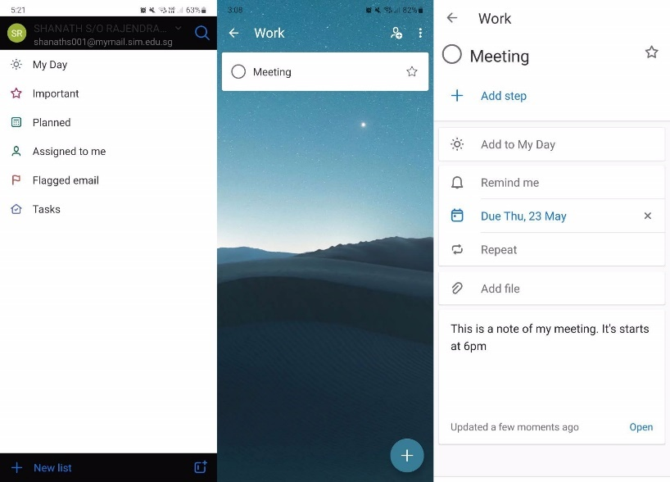

Figure Microsoft To Do

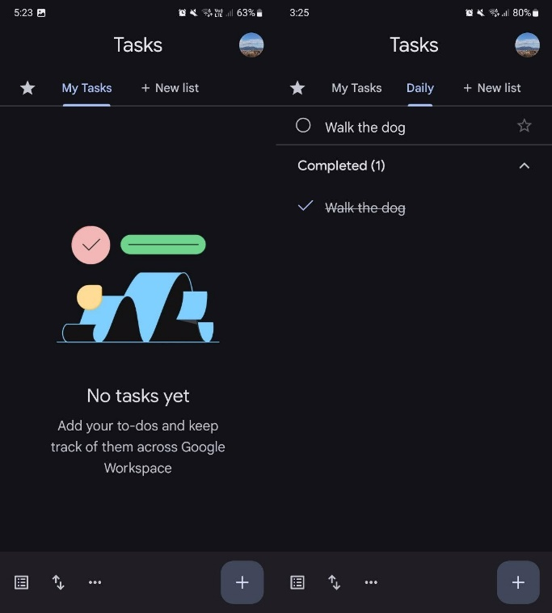

Figure Google Tasks

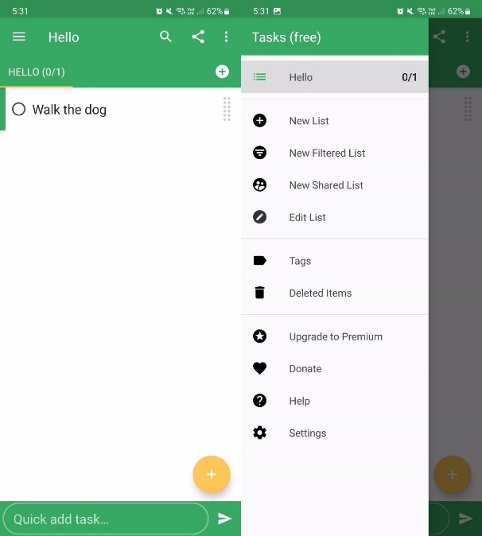

Figure Tasks by Pocket Brilliance

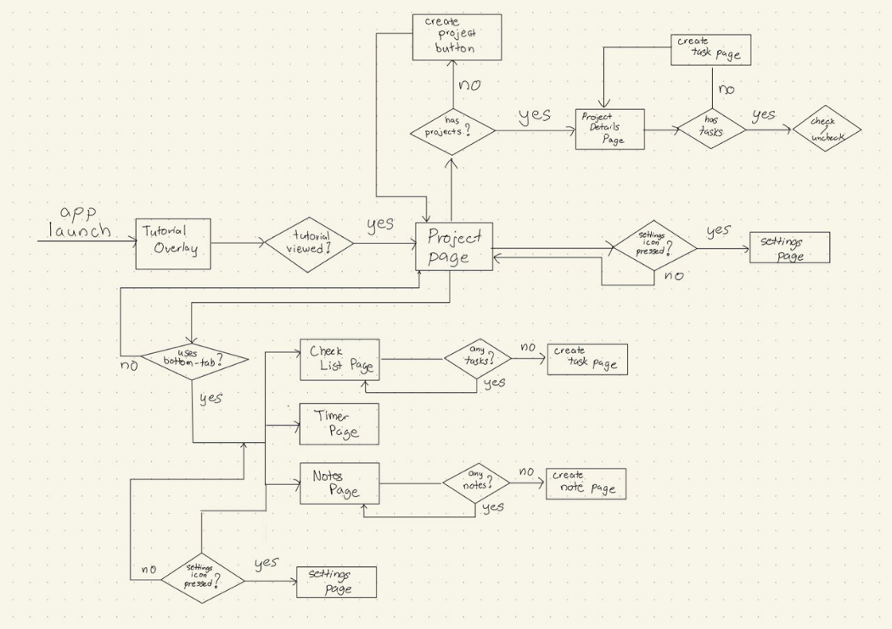

Figure User Flow

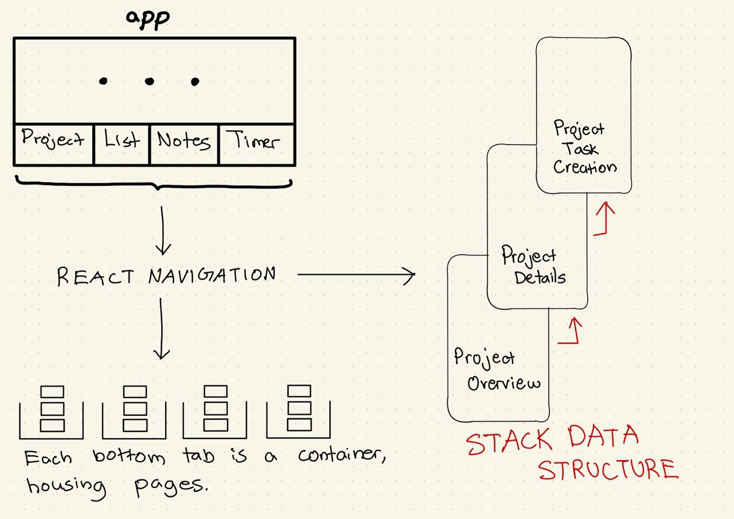

Figure React Navigation Overview

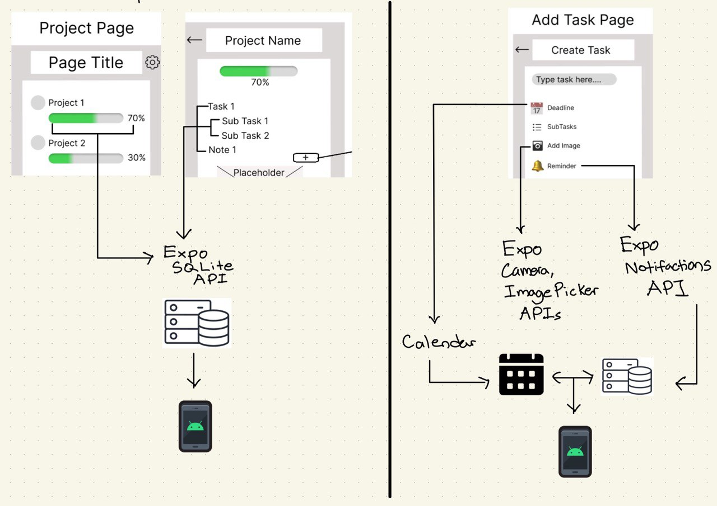

Figure Project Tab Structure

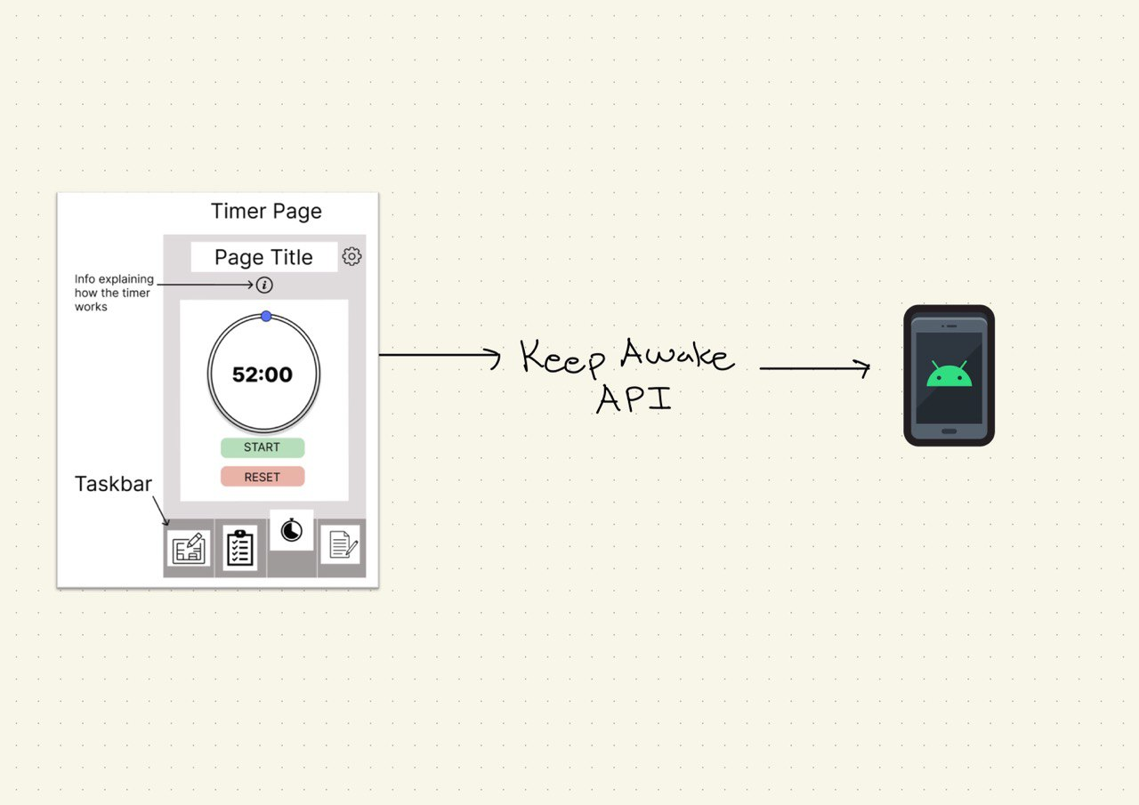

Figure Focus Tool Overview

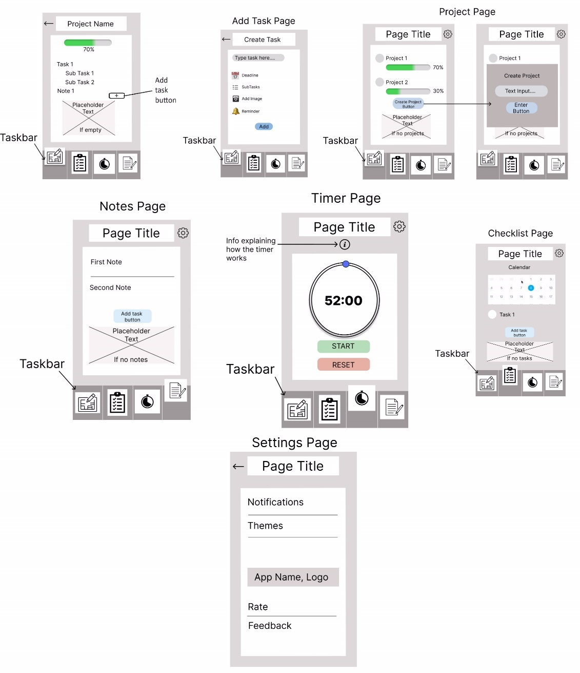

Figure Low Fidelity Wireframe

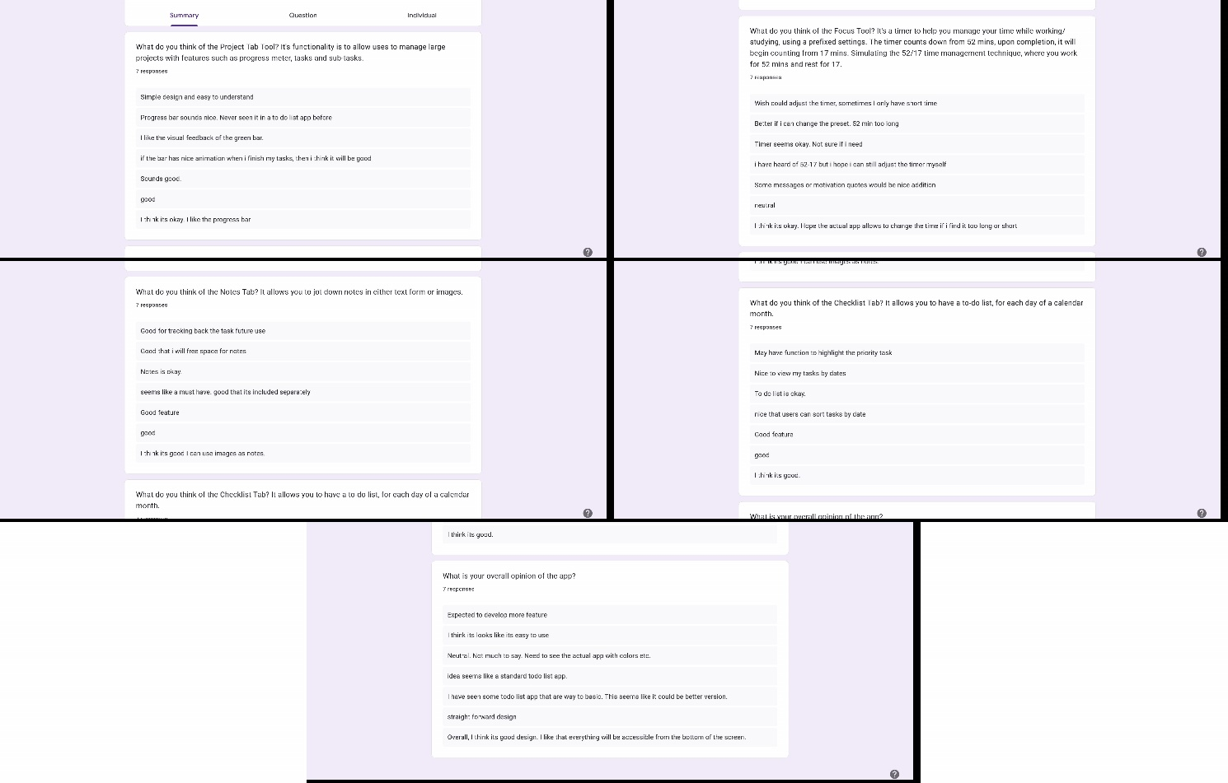

Figure Google Survey

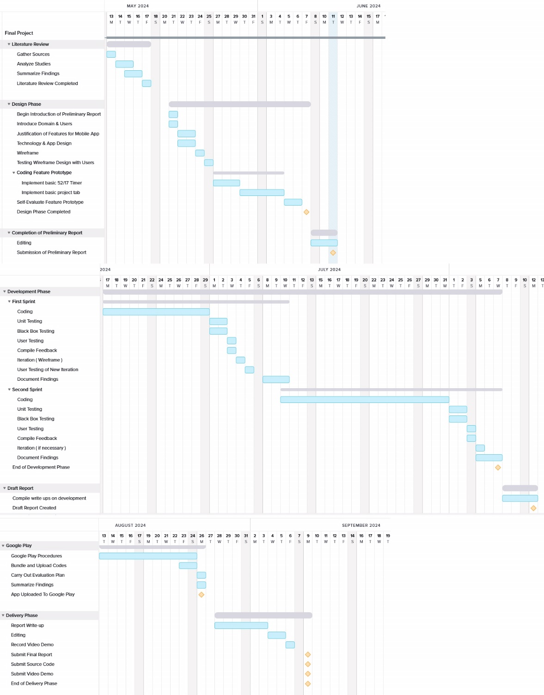

Figure Gantt Chart

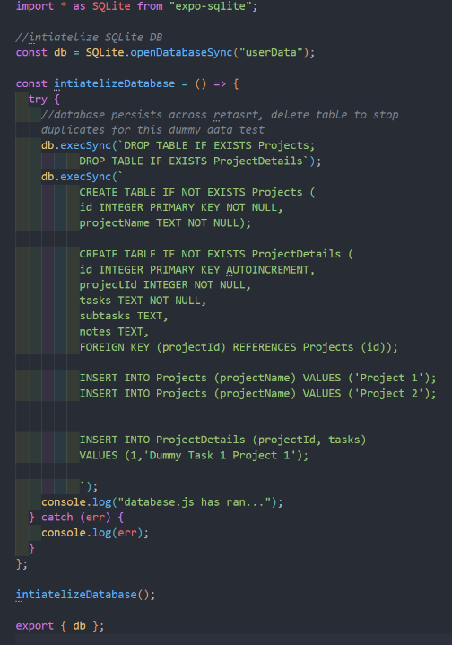

Figure SQLite Snippet

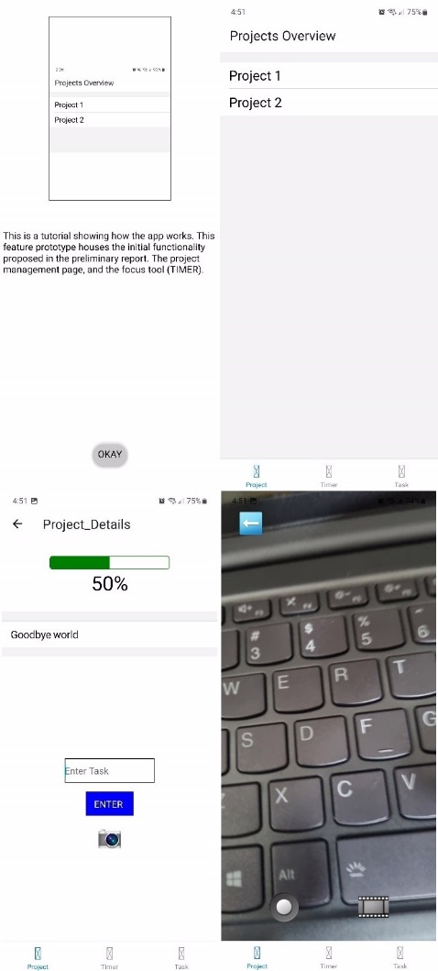

Figure Prototype Showcase

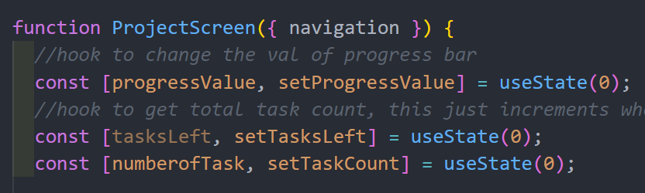

Figure Project Screen Code Snippet

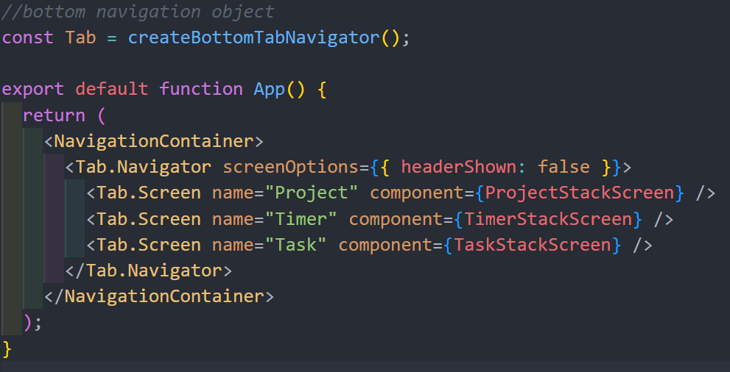

Figure Stack Navigator Code Snippet

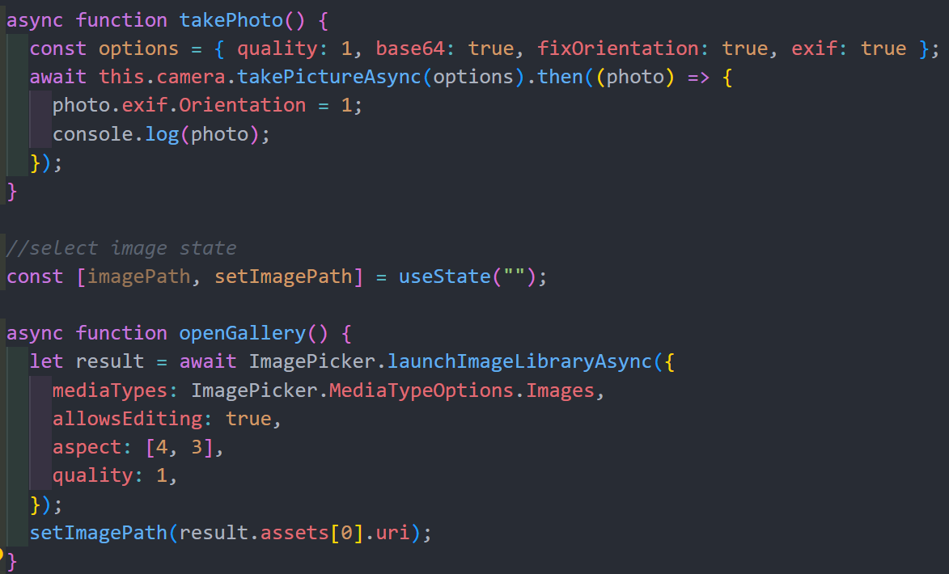

Figure Camera API Snippet

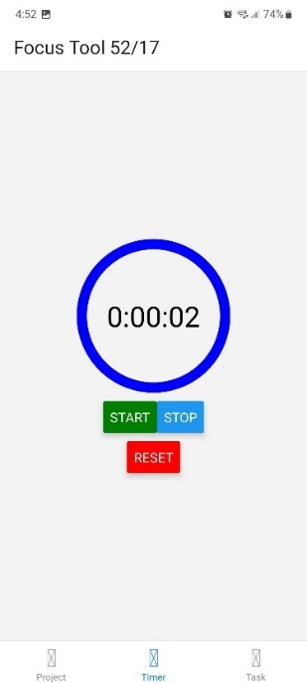

Figure Focus Timer Tool

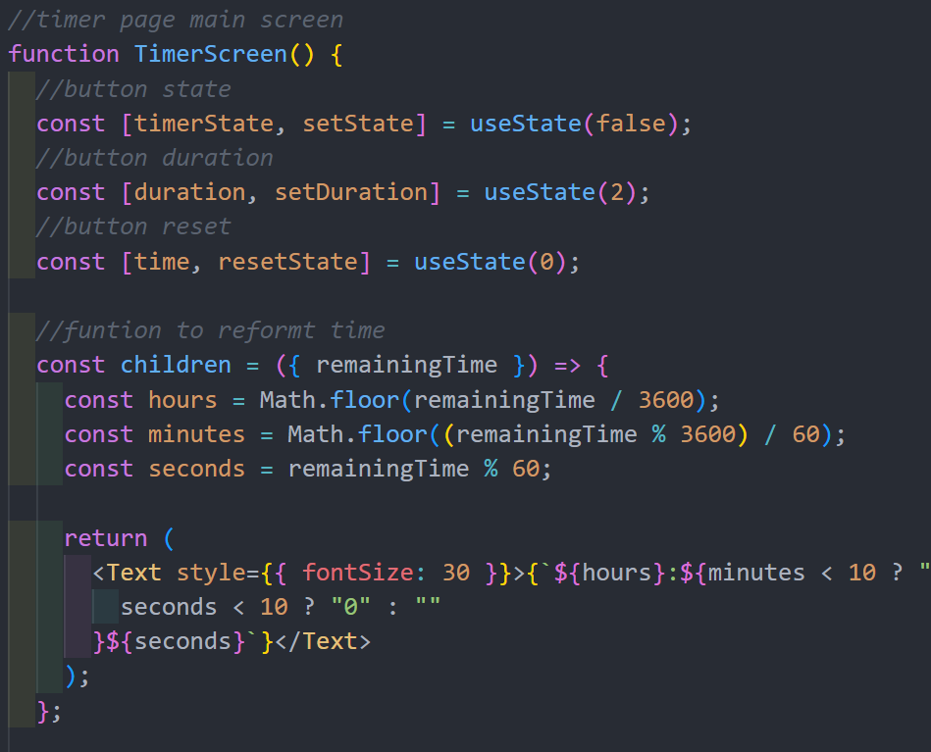

Figure Timer Logic